# HOL 3 : Deploying Two-Tier ASP.NET and MSSQL Application on Windows

**Objective:**

**Learn multi-application container deployment using ‘docker-compose’ on Windows Hosts. This lab uses sample application shared on GitHub to ease the overall deployment experience. Please read the contents of docker-compose.yaml to understand the overall deployment environment.**

**Duration: 30 Minutes**

**Prerequisites:**

1. Azure Subscription
2. Internet Connection
3. SSH Client (Ubuntu Bash or Git Bash)
4. Web Browser (Any)
5. Text editor (Visual Studio code recommended)

**Steps:**

1. Launch DockerVM1 created earlier for HOL1
2. Once inside, open internet explorer to open following URL

<https://github.com/mahendra-shinde/mssql-aspnet-docker-demo-app>

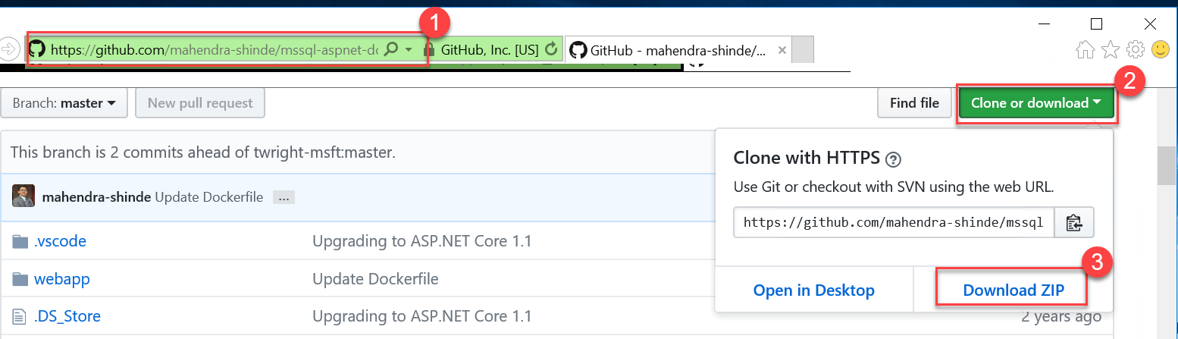

Click on “clone or download” and then “Download ZIP”

1. Click “Open folder” to open downloads folder where ZIP file got downloaded.

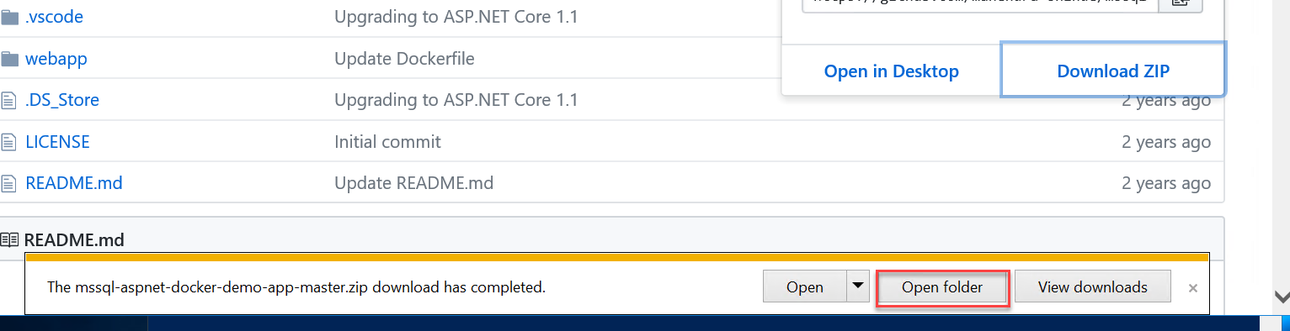

1. Extract the contents of ZIP

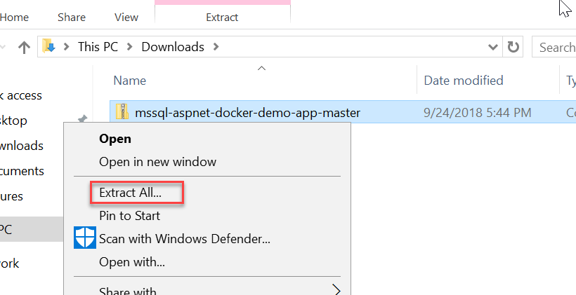

1. Open the folder where files are extracted and then open powershell

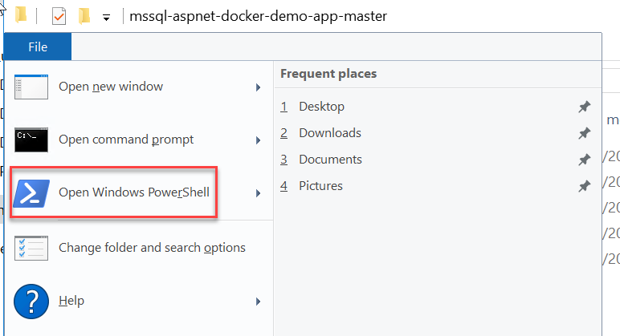

1. Open “webapp” subfolder there should be TWO files inside : Dockerfile & docker-compose.yml

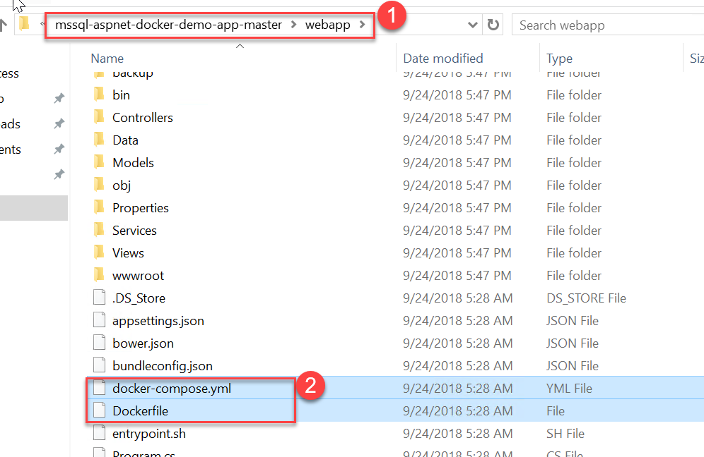

1. Review the contents of Dockerfile using “wordpad”

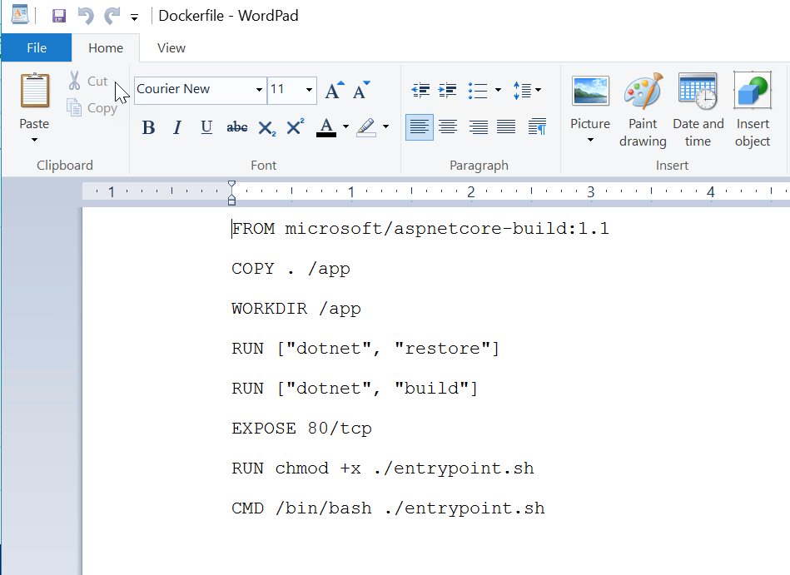

1. Review the contents of docker-compose.yml file

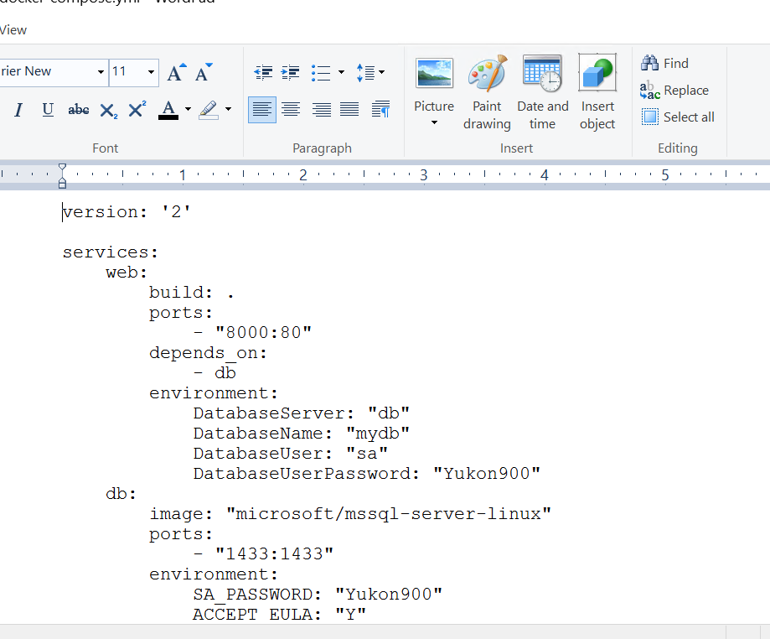

NOTE : change version from “2” to “2.1” and save file

1. Switch back to windows explorer where “webapps” folder is open, Use file menu for “Open Powershell



1. Build and run the application using docker-compose up using powershell

$ docker-compose up -d

1. Wait for containers to spin up and then try visiting http://<PUBLIC-IP>:8000 from host browser

